Data Sheet

OP Series Ovens

Features

- PID control with display of actual and set temperature
- Stainless steel radiused interior
- Adjustable shelf positions
- Adjustable vent
- Auto-recovery options
- Class 2 over temperature protection

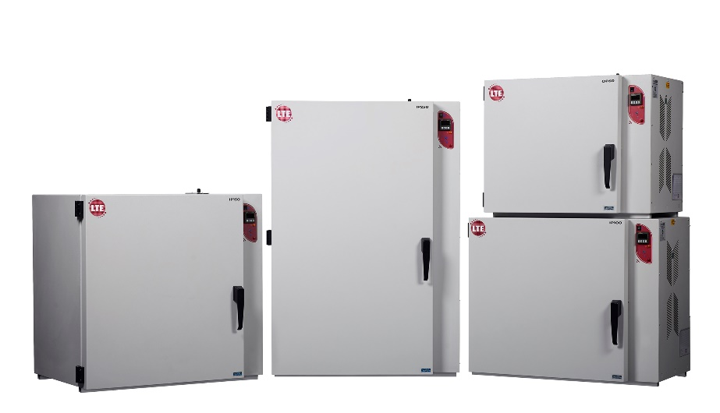

Cat. No. | OP60-U  OP60-UF  OP60-M  OP60-MF | OP100-U  OP100-UF  OP100-M  OP100-MF | OP150-U  OP150-UF  OP150-M  OP150-MF | OP250-U  OP250-UF  OP250-M  OP250-MF
Capacity (litres) | 60 | 100 | 150 | 250
Shelves Included | 2 | 2 | 2 | 3
Temp. Range, ˚C | 40 to 250 | 40 to 250 | 40 to 250 | 40 to 250
Internal Dims, HWD mm | 400 x 400 x 400 | 500 x 500 x 400 | 600 x 500 x 500 | 1000 x 500 x 500
External Dims, HWD mm | 590 x 735 x 575 | 690 x 835 x 575 | 790 x 835 x 675 | 1190 x 835 x 675

The above is the standard specification. Any modification/deviation for the above will be clearly identified on the quotation front sheet

